Sub-queries
The database used in this lab is internal. You will be working on a sample HR database. This HR database schema consists of 5 tables: EMPLOYEES, JOB_HISTORY, JOBS, DEPARTMENTS, and LOCATIONS. Each table has a few rows of sample data. The following diagram shows the tables for the HR database:
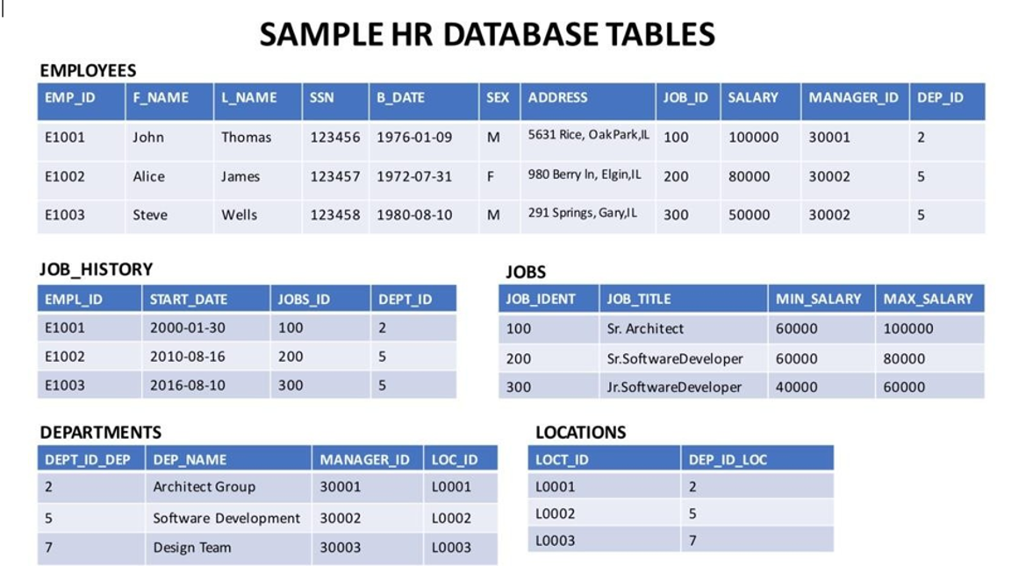

Load the database
- Create a blank database named 'HR'. Use the script shared in the link below to create the required tables.
Script_Create_Tables.sql
- Download the files in the links below to your local device (if not already done in previous class)
Departments.csv
Jobs.csv
JobsHistory.csv
Locations.csv
Employees.csv

CREATE TABLE EMPLOYEES (
EMP_ID CHAR(9) NOT NULL,
F_NAME VARCHAR(15) NOT NULL,
L_NAME VARCHAR(15) NOT NULL,
SSN CHAR(9),
B_DATE DATE,
SEX CHAR,
ADDRESS VARCHAR(30),
JOB_ID CHAR(9),
SALARY DECIMAL(10,2),
MANAGER_ID CHAR(9),
DEP_ID CHAR(9) NOT NULL,
PRIMARY KEY (EMP_ID));

CREATE TABLE JOB_HISTORY (
EMPL_ID CHAR(9) NOT NULL,
START_DATE DATE,
JOBS_ID CHAR(9) NOT NULL,
DEPT_ID CHAR(9),
PRIMARY KEY (EMPL_ID,JOBS_ID));

CREATE TABLE JOBS (
JOB_IDENT CHAR(9) NOT NULL,
JOB_TITLE VARCHAR(30),
MIN_SALARY DECIMAL(10,2),
MAX_SALARY DECIMAL(10,2),
PRIMARY KEY (JOB_IDENT));

CREATE TABLE DEPARTMENTS (
DEPT_ID_DEP CHAR(9) NOT NULL,
DEP_NAME VARCHAR(15) ,
MANAGER_ID CHAR(9),
LOC_ID CHAR(9),
PRIMARY KEY (DEPT_ID_DEP));

CREATE TABLE LOCATIONS (
LOCT_ID CHAR(9) NOT NULL,
DEP_ID_LOC CHAR(9) NOT NULL,
PRIMARY KEY (LOCT_ID,DEP_ID_LOC));

Exercise:
- Execute a working query using a sub-select to retrieve all employees records whose salary is lower than the average salary.
- Execute a Column Expression that retrieves all employees’ records with EMP_ID, SALARY and maximum salary as MAX_SALARY in every row.
- Write a query to find the average salary of the five least-earning employees.
- Write a query to find the records of employees older than the average age of all employees.
- From the Job History table, display the list of Employee IDs, years of service, and average years of service for all entries.
- Retrieve only the EMPLOYEES records that correspond to jobs in the JOBS table.
- Retrieve only the list of employees whose JOB_TITLE is Jr. Designer.
- Retrieve JOB information and who earn more than $70,000.
- Retrieve JOB information and whose birth year is after 1976.
- Retrieve JOB information for female employees whose birth year is after 1976.

